**31** **THREE CANADIAN CITIES**

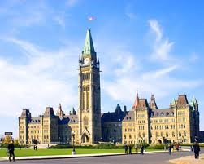 Ottawa, the capital city of Canada, is a wonderful mixture of old and new buildings**. This green city** is a cultural and a historical center. The people are friendly and speak both French and English. The

**5** population is over 870,000. Parliament Hill is a popular tourist spot. It attracts about three million visitors every year. Visitors can watch military parades **there**. Ottawa is also the home of Canada’s National Gallery. There are beautiful gardens around

**10** it. Inside, visitors can see over 25,000 famous works of art from around the world. With more than 25 other museums, 60 annual festivals and a wildlife park, Ottawa is a great city to visit.

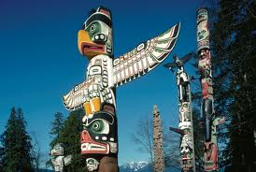Vancouver is one of the most beautiful places in

**15** Canada. It has clean streets and green parks and great views of the Pacific Ocean to the west, and huge mountains to the east. Vancouver is an ideal city to live in. It has a warm climate. The summer months are dry, but

**20** the autumn and winter months are rainy. One of its main attractions is Stanley Park. There are sandy beaches, lakes, and even Indian totem poles there. Canada Place is another attraction. **It** is a Canadian icon. It has a conference center, a luxury hotel, lots of shops, and a huge cinema. Special events

**25** are held **there** all year round.

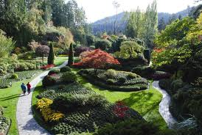The city of Montreal is sometimes called “the Paris of North America.” Two-thirds of the population speaks French. The part called Old Montreal is very popular with tourists because

**30** it has very narrow streets, old buildings, and

European-style cafés and restaurants. The Botanical Garden is just minutes from Montreal, right near Olympic Park. In the Botanical Garden, there are over 22,000 types of plants

**35** and flowers from all over the world. You can visit **it** in any season.

**PART A. Read the text and write the name of the city that matches the given information in the text.**

1. It has a view of the Pacific Ocean. _____________
2. There are 60 festivals every year. _____________
3. The old part of the city has narrow streets. _____________
4. People in this city are friendly. _____________
5. This city is the Paris of North America. _____________
6. The streets in this city are very clean. _____________

**PART B. What do the following refer to?**

1. Line 2, **‘This green city’** means _____________________
2. Line 8, **‘there’** means _____________________
3. Line 23, ‘**it’** means _____________________
4. Line 25**, ‘there’** means _____________________
5. Line 36**, ‘it’** means _____________________

**PART C. Read about the cities again, and answer the questions with complete sentences.**

1. How can you describe the buildings in Ottawa?

________________________________________________________

2. How many tourists visit the city every year?

________________________________________________________

3. How many museums are there in Ottawa?

________________________________________________________

4. Are the mountains near Vancouver east or west of the city?

________________________________________________________

5. What is the weather like in Vancouver in July?

________________________________________________________

6. Where can you see Indian totem poles in Vancouver?

________________________________________________________

7. Which language does most of the population speak in Montreal?

________________________________________________________

8. Is the Botanical Garden far from Montreal?

________________________________________________________

9. What can you see there?

________________________________________________________

10. Can you visit it in winter?

________________________________________________________

**38 FAVORITE PASTIMES OF AUSTRALIAN CHILDREN**

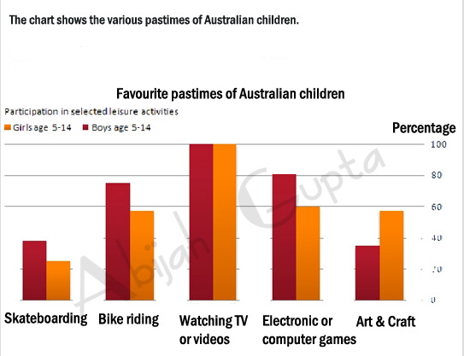

**Look at the bar graph, and complete the following sentences. Don’t forget to use the expressions nearly, over, exactly,and about where necessary.**

1. The graph shows the various pastimes of Australian children between the ages of _______________________.

2. A hundred percent of ____________ and ____________ watch TV or videos.

3. _______________________ of boys play electronic or computer games.

4. _______________________ of girls are interested in arts and crafts.

5. _______________ twenty percent of girls do _____________________.

6. Nearly 80% of boys like _________________________________________.